Cybersecurity Analyst Internship
Task Report

[samfelix15@gmail.com]
Task No: [18 - Mobile Security Basics]

Copyright © 2024 EncryptEdge Labs. All rights reserved
Credit: Offensive Security

Table of Contents
1.0 EncryptEdge Labs Internship Task Report 2
1.1 Introduction 3
1.2 Objective 3
1.3 Requirements 4
2.0 High-Level Summary 10
2.1 Recommendations 10
2.2 Risk exposure over time 11
3.0 Report - Methodologies 12
3.1 Information Gathering 13
4.0 Additionals Item X
1.0 EncryptEdge Labs Internship Task Report
1.1 Introduction
Mobile security has become a critical concern in today's digital age. With the rapid proliferation of mobile devices, including smartphones and tablets, mobile security has emerged as a key challenge for individuals, organizations, and governments. The history of mobile security dates back to the early 2000s, when mobile devices first became widely available. Initially, mobile security focused on protecting devices from malware and other threats. However, as mobile devices have become increasingly sophisticated and ubiquitous, mobile security has evolved to address a wide range of threats, including data breaches, unauthorized access, and malicious apps.
The importance of mobile security cannot be overstated. Mobile devices are used for a wide range of activities, including communication, entertainment, and productivity. As a result, mobile devices often contain sensitive information, such as personal data, financial information, and confidential business data. If this information falls into the wrong hands, it can have serious consequences, including identity theft, financial loss, and reputational damage.

1.2 Objective
The objectives of mobile security are to:
1. Protect Mobile Devices: Protect mobile devices from malware, unauthorized access, and other threats.
2. Secure Mobile Data: Secure mobile data, including personal and confidential business information.
3. Prevent Data Breaches: Prevent data breaches and unauthorized access to sensitive information.
4. Ensure Compliance: Ensure compliance with regulatory requirements and industry standards related to mobile security.
To achieve these objectives, mobile security solutions employ various technologies and techniques, including encryption, authentication, and threat detection.
In this, the main objective is to,
Understand the unique challenges in mobile security.
Learn fundamental principles of securing mobile devices and applications.
Gain practical experience in identifying and mitigating security risks in mobile environments.

1.3 Requirements
Effective mobile security requires several key components, including:
1. Mobile Device Management (MDM): MDM solutions enable organizations to manage and secure mobile devices, including configuring security settings, installing apps, and wiping data remotely.
2. Mobile Application Management (MAM): MAM solutions enable organizations to manage and secure mobile apps, including distributing apps, configuring app settings, and monitoring app activity.
3. Mobile Threat Defense (MTD): MTD solutions enable organizations to detect and respond to mobile threats, including malware, unauthorized access, and other malicious activity.
4. Encryption: Encryption solutions enable organizations to protect mobile data, including data stored on devices and data transmitted over mobile networks.
By implementing these components, organizations can ensure the security and integrity of their mobile devices and data.
With reference to this task I am to submit,
- A summary of mobile security challenges and best practices.
- A comparison of Android vs. iOS security and a summary of MDM and mobile network security.
- Screenshots of the lab setup, tools used, and network traffic analysis

- Documentation and screenshots of the vulnerabilities identified and mitigation steps taken.
- A report analyzing a real-world mobile breach and a description of the simulated attacks and their defenses.

Tools used in this report will include
Mobile devices (emulators or physical devices).
Basic mobile security testing tools (OWASP Mobile Security Testing Guide, MobSF, Drozer).
Wireshark or similar network monitoring tools.
Mobile Device Management (MDM) solutions (optional).

A Comprehensive Analysis of Challenges Relative To Mobile Security
Mobile security has become a critical concern in today's digital age. With the rapid proliferation of mobile devices, including smartphones and tablets, mobile security has emerged as a key challenge for individuals, organizations, and governments. Mobile devices are vulnerable to a wide range of threats, including malware, unauthorized access, and data breaches. In this essay, we will provide an in-depth analysis of the challenges of mobile security and explore the various threats and vulnerabilities that mobile devices face.
Device Diversity
One of the primary challenges of mobile security is device diversity. Mobile devices come in a wide range of shapes, sizes, and operating systems, making it challenging to implement effective mobile security solutions. Different devices have different security features, and some devices may be more vulnerable to certain types of threats. For example, Android devices are more vulnerable to malware threats due to the open nature of the Android operating system.
User Behavior
User behavior is another significant challenge for mobile security. Many users are unaware of the potential security risks associated with mobile devices and may engage in behaviors that put their devices and data at risk. For example, users may download apps from untrusted sources, click on phishing links, or fail to update their devices with the latest security patches. These behaviors can increase the risk of mobile security threats and make it more challenging for organizations to protect their mobile devices and data.
Limited Resources
Mobile devices have limited resources, including processing power, memory, and battery life, which can make it challenging to implement effective mobile security solutions. Many mobile security solutions require significant resources, including processing power and memory, which can drain the battery and slow down the device. As a result, mobile security solutions must be designed to be lightweight and efficient, while still providing effective protection against mobile security threats.
Malware Threats
Malware threats are a significant challenge for mobile security. Malware is malicious software that can be installed on a mobile device without the user's knowledge or consent. Malware can steal sensitive information, including login credentials and financial information, and can also be used to gain unauthorized access to mobile devices. Mobile malware can spread through various channels, including app stores, phishing emails, and infected websites.
Unauthorized Access
Unauthorized access is another significant challenge for mobile security. Mobile devices can be vulnerable to unauthorized access, including hacking and data theft. Unauthorized access can occur through various channels, including weak passwords, phishing attacks, and malware. Once an attacker gains unauthorized access to a mobile device, they can steal sensitive information, install malware, or use the device for malicious purposes.
Data Breaches
Data breaches are a significant challenge for mobile security. Mobile devices often contain sensitive information, including personal data, financial information, and confidential business data. If this information falls into the wrong hands, it can have serious consequences, including identity theft, financial loss, and reputational damage. Data breaches can occur through various channels, including hacking, malware, and unauthorized access.

Comparison of Android and iOS Security:
The security of mobile devices is a critical concern in today's digital age. Two of the most popular mobile operating systems, Android and iOS, have distinct security features and challenges. In this essay, we will provide a comprehensive analysis of the security features and challenges of Android and iOS, highlighting the key differences between the two operating systems.
Security Architecture
One of the primary differences between Android and iOS security is the security architecture. Android has a more open architecture than iOS, which can make it more vulnerable to security threats. Android's open architecture allows users to install apps from outside the Google Play Store, which can increase the risk of malware infections. iOS, on the other hand, has a more closed architecture, which can make it more secure. iOS devices can only install apps from the App Store, which are reviewed and approved by Apple.
App Review Process
The app review process is another key difference between Android and iOS security. iOS has a strict app review process, which can help to prevent malicious apps from being distributed. Apple reviews and approves all apps before they are released on the App Store, which can help to ensure that apps are free from malware and other security threats. Android also has an app review process, but it is not as strict as iOS. Google Play Store has a review process, but it is not as comprehensive as Apple's.
Encryption
Both Android and iOS offer encryption features to protect user data. However, iOS is more comprehensive in its encryption approach. iOS devices use end-to-end encryption to protect data stored on the device, as well as data transmitted over the internet. Android devices also offer encryption, but it is not as comprehensive as iOS.
Malware Protection
Malware protection is another key difference between Android and iOS security. Android devices are more vulnerable to malware threats due to the open nature of the Android operating system. iOS devices, on the other hand, are less vulnerable to malware threats due to the closed architecture and strict app review process.
User Authentication
User authentication is an essential security feature for both Android and iOS devices. Both operating systems offer various authentication methods, including passwords, biometrics, and two-factor authentication. However, iOS devices have a more comprehensive biometric authentication system, including Face ID and Touch ID.

Summary of MDM and Mobile Network
MDM solutions enable organizations to manage and secure mobile devices, including configuring security settings, installing apps, and wiping data remotely. Some key features of MDM solutions include:
Device Enrollment: Device enrollment enables organizations to enroll mobile devices in the MDM solution, which allows for centralized management and security.
Policy Management: Policy management enables organizations to configure security policies for mobile devices, including password requirements, app restrictions, and data encryption.
App Management: App management enables organizations to manage and distribute apps to mobile devices, including public apps, private apps, and in-house apps.

Report Analyzing a Real-World Mobile Breach
One example of a real-world mobile breach is the 2019 WhatsApp vulnerability that allowed attackers to install spyware on devices through a voice call. The vulnerability was caused by a buffer overflow bug in WhatsApp's VoIP feature, which allowed attackers to execute malicious code on devices.
The breach highlights the importance of mobile security and the need for organizations to implement effective mobile security solutions. Some key takeaways from the breach include:
Importance of Patching: The breach highlights the importance of patching mobile devices and apps to ensure that they have the latest security fixes.
Need for Mobile Security Solutions: The breach highlights the need for organizations to implement mobile security solutions, including MDM and MTD, to protect mobile devices and data.
Importance of User Awareness: The breach highlights the importance of user awareness and education on mobile security best practices, including avoiding suspicious links and messages.
By analyzing real-world mobile breaches, organizations can gain insights into mobile security threats and develop effective mobile security strategies.

2.0 High-Level Summary
Mobile security is a critical concern for individuals, organizations, and governments. Mobile devices are vulnerable to a wide range of threats, including malware, unauthorized access, and data breaches. To protect mobile devices and data, organizations can implement various mobile security solutions, including MDM, MAM, MTD, and encryption. By understanding the importance of mobile security and implementing effective mobile security solutions, organizations can protect their mobile devices and data from various threats.
Secondly, mobile security is a complex and challenging field that requires a comprehensive approach to protect mobile devices and data. The challenges of mobile security, including device diversity, user behavior, limited resources, malware threats, unauthorized access, and data breaches, require organizations to implement effective mobile security solutions. By understanding the challenges of mobile security and implementing effective mobile security solutions, organizations can protect their mobile devices and data from various threats and ensure the security and integrity of their mobile ecosystem. ‎
In conclusion, both Android and iOS have their own security features and challenges. Android's open architecture can make it more vulnerable to security threats, while iOS's closed architecture can make it more secure. The app review process, encryption, malware protection, and user authentication are all essential security features that differ between the two operating systems. By understanding the security features and challenges of Android and iOS, users can make informed decisions about which operating system is best for their needs.

2.1 Recommendations
Based on the analysis above, here are some recommendations for users and organizations:
Use a combination of security features: Both Android and iOS devices can benefit from a combination of security features, including passwords, biometrics, and two-factor authentication.
Keep software up-to-date: Keeping software up-to-date is essential for both Android and iOS devices. Regular updates can help to patch security vulnerabilities and prevent malware infections.
Use secure apps: Users should only install apps from trusted sources, such as the App Store or Google Play Store. Apps should be reviewed and approved before installation to ensure they are free from malware and other security threats.
Eencryption: Encryption is an essential security feature for both Android and iOS devices. Users should enable encryption to protect their data and prevent unauthorized access.
By following these recommendations, users and organizations can help to protect their mobile devices and data from various security threats

2.2 Risk Exposure over Time
The risk exposure associated with mobile security has increased significantly over time, driven by several factors, including:
1. Increased Mobile Device Use: The increased use of mobile devices has expanded the attack surface, providing more opportunities for attackers to exploit vulnerabilities.
2. Sophisticated Threats: The sophistication of mobile threats has increased, making it more challenging for organizations to detect and respond to security incidents.
3. Regulatory Requirements: The regulatory requirements related to mobile security have increased, making it essential for organizations to implement effective mobile security solutions.
To mitigate these risks, organizations must prioritize mobile security and implement effective mobile security solutions.

3.0 Methodologies
Implementing effective mobile security requires a comprehensive methodology that includes:
1. Risk Assessment: Conduct a risk assessment to identify potential mobile security threats and vulnerabilities.
2. Solution Selection: Select mobile security solutions that meet the organization's specific needs and requirements.
3. Implementation: Implement mobile security solutions, including configuring security settings, installing apps, and wiping data remotely.
4. Monitoring and Analysis: Continuously monitor and analyze mobile security activity to detect and respond to potential threats.
5. Incident Response: Develop and implement incident response procedures to quickly respond to mobile security incidents.
By following this methodology, organizations can ensure the security and integrity of their mobile devices and data.

3.1 Information Gathering
Effective mobile security requires the collection and analysis of various types of data, including:
1. Device Data: Collect data from mobile devices, including device type, operating system, and app activity.
2.Network Data: Collect data from mobile networks, including network traffic and connectivity information.
3. Threat Intelligence: Collect threat intelligence data, including information about known threats and vulnerabilities.
4.Incident Data : Collect incident data, including information about security incidents and breaches.
By gathering and analyzing this data, organizations can gain insights into mobile security threats and vulnerabilities and develop effective mobile security strategies.

4.0 Additional Items
This section will include screenshots of completed lab assignments on the TryHackMe platform. This includes Android Hacking 101 & Mobile Malware Analysis.

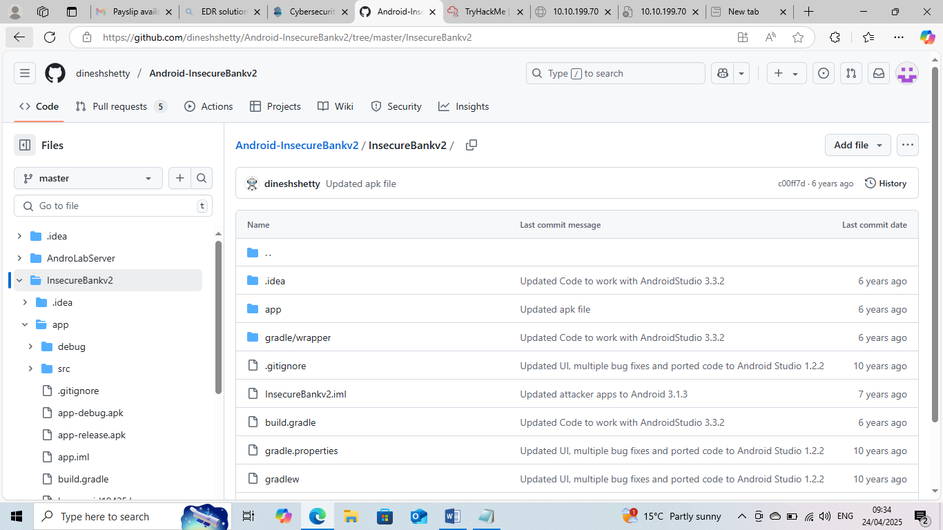
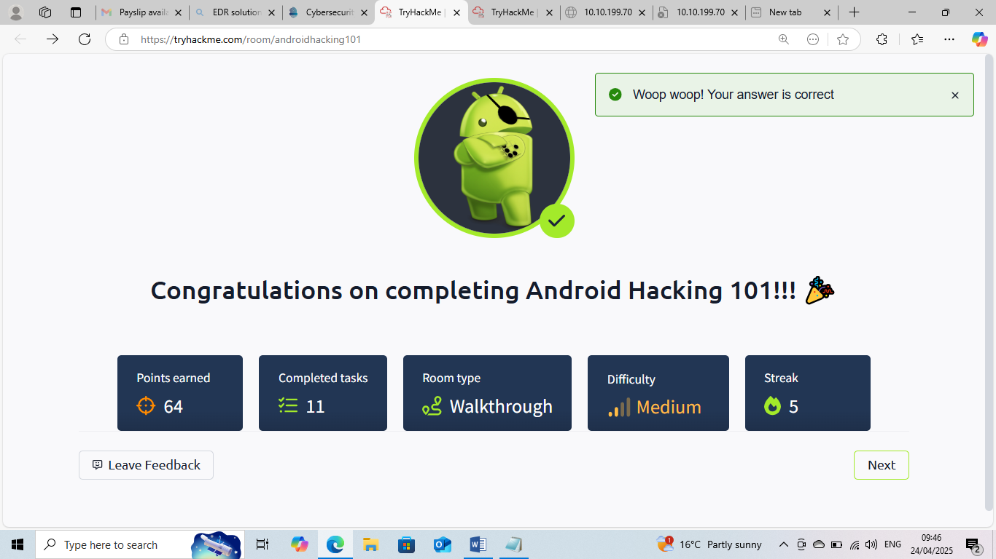

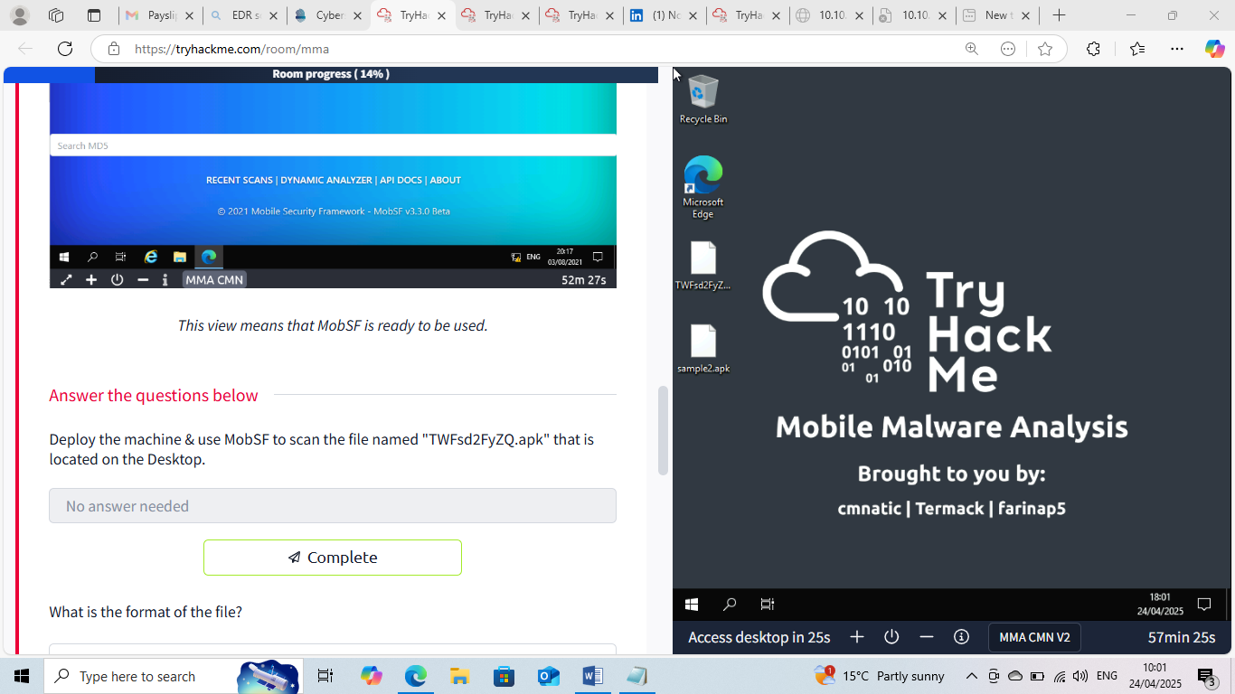

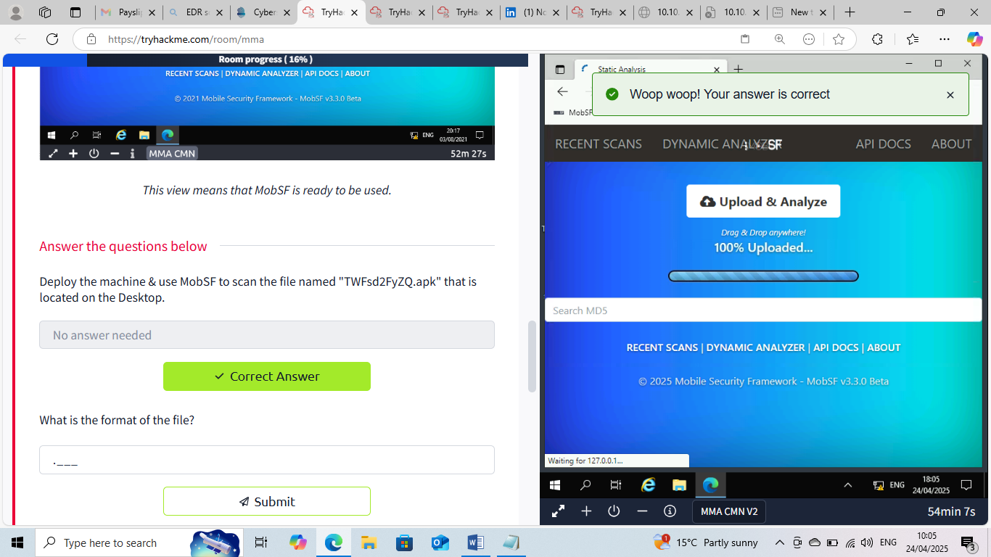

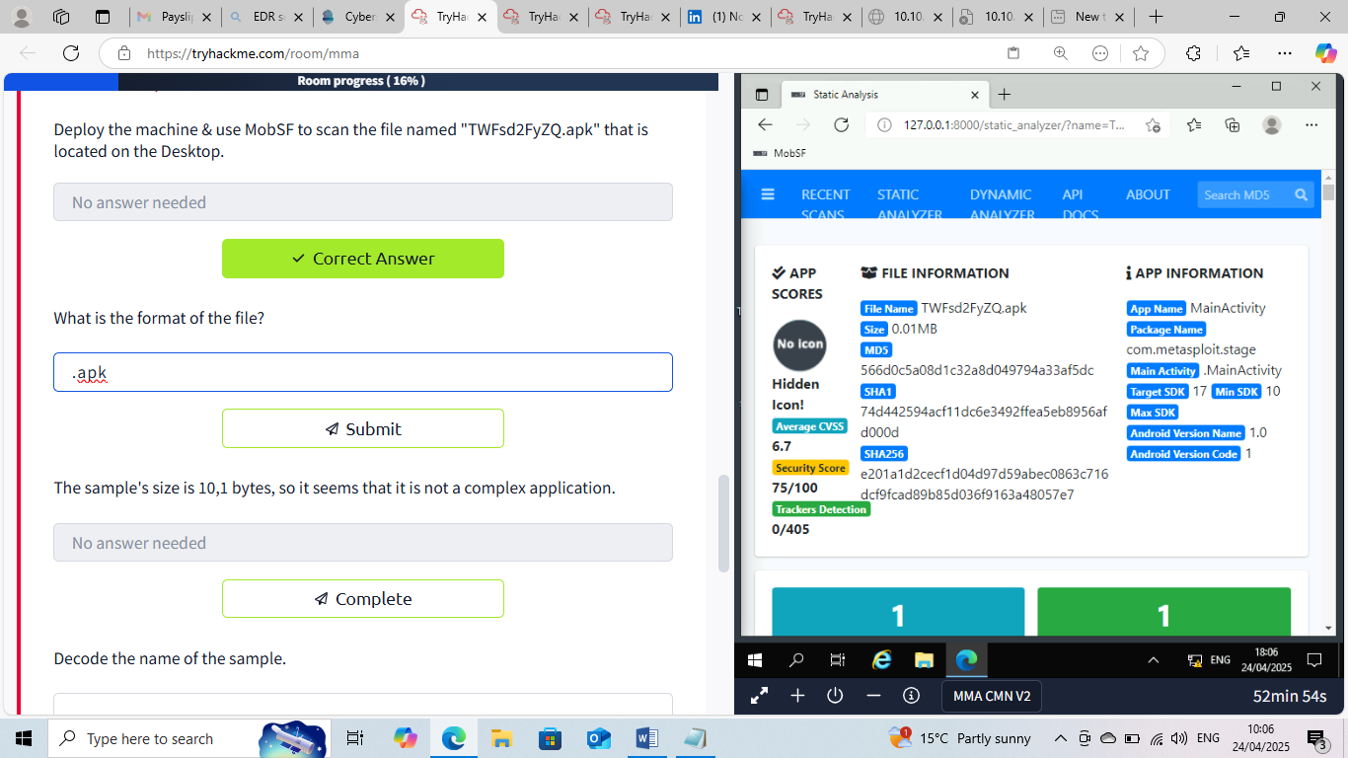

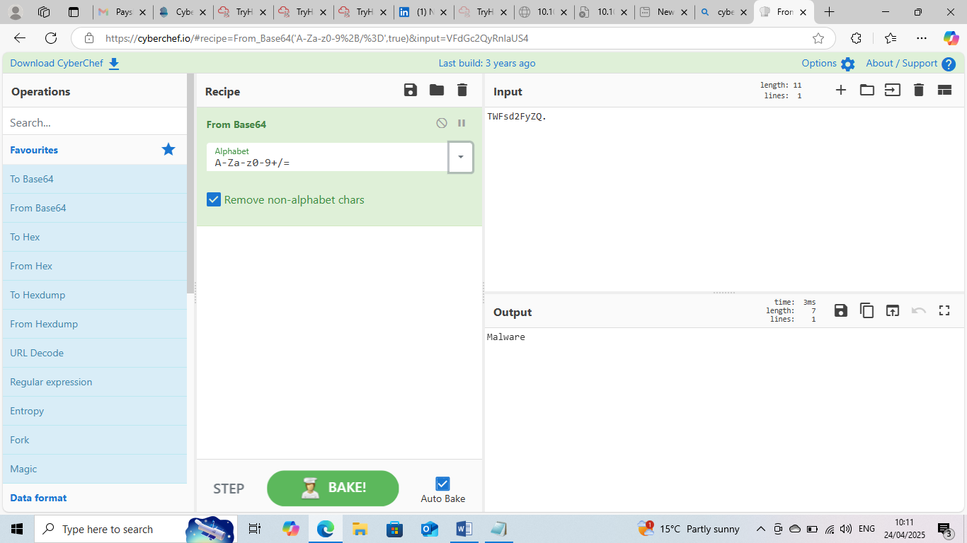

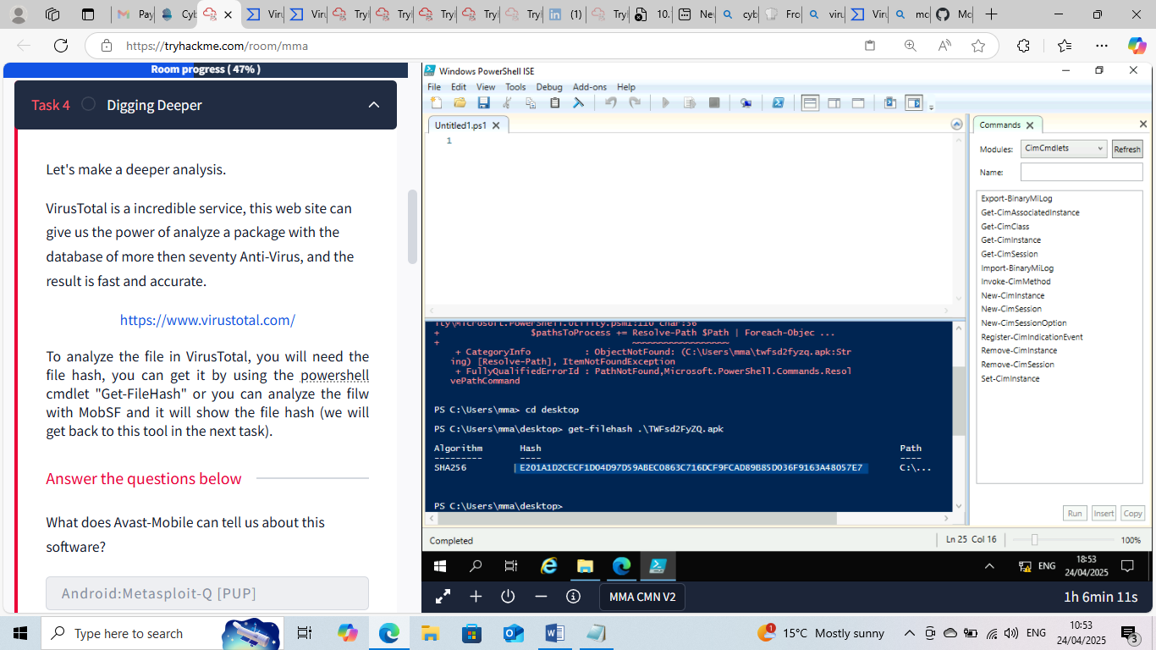

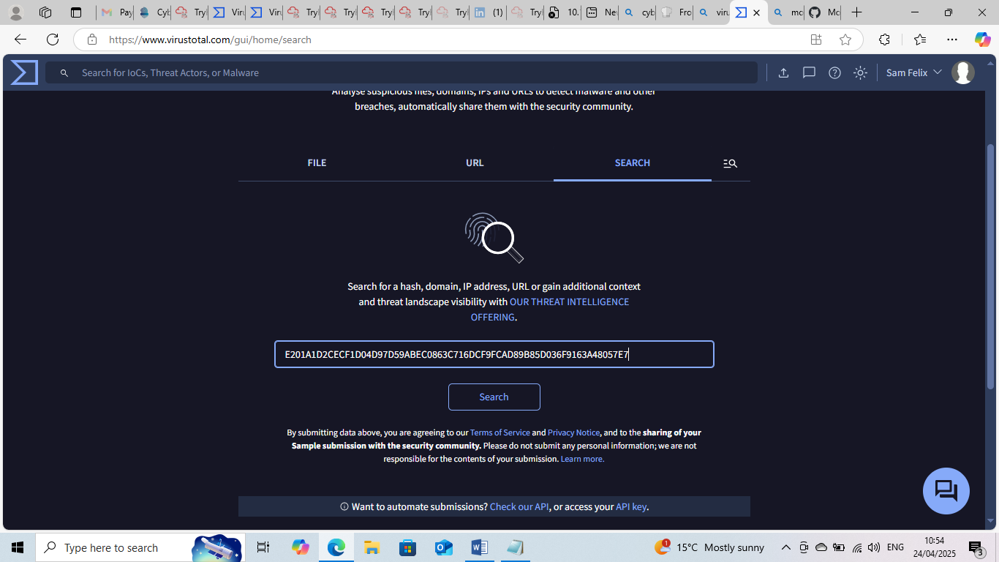

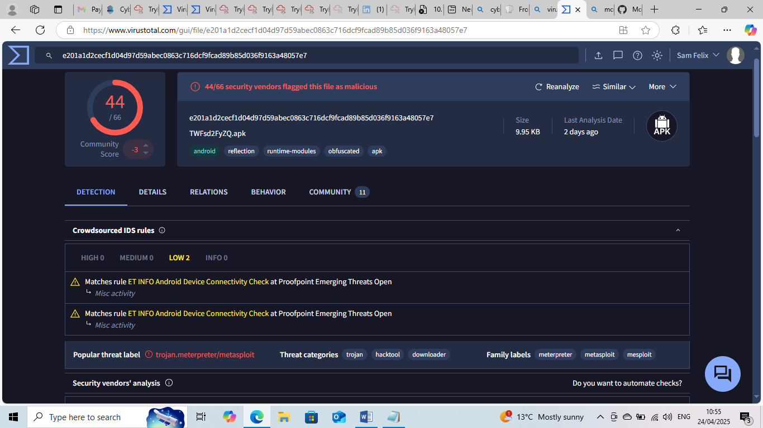

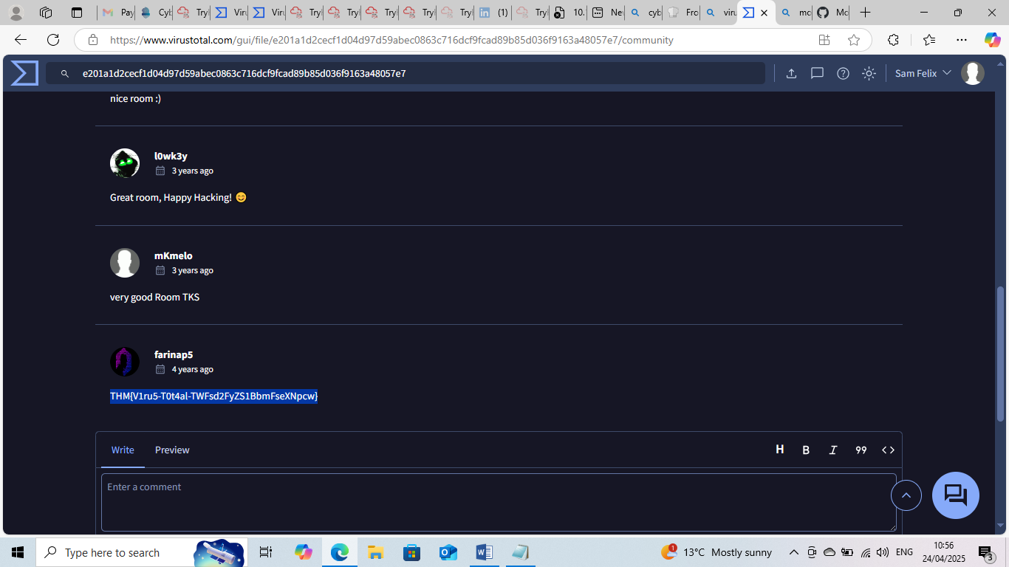

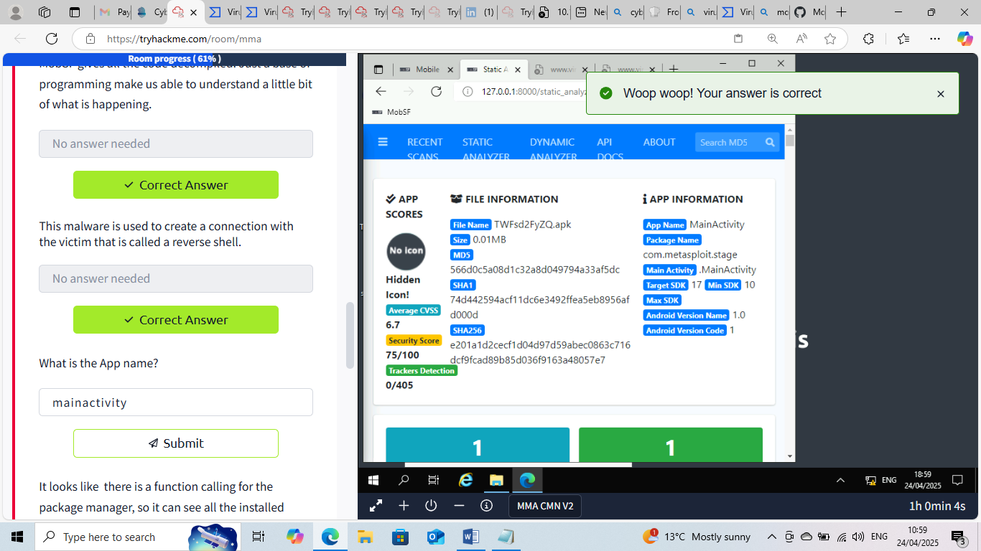

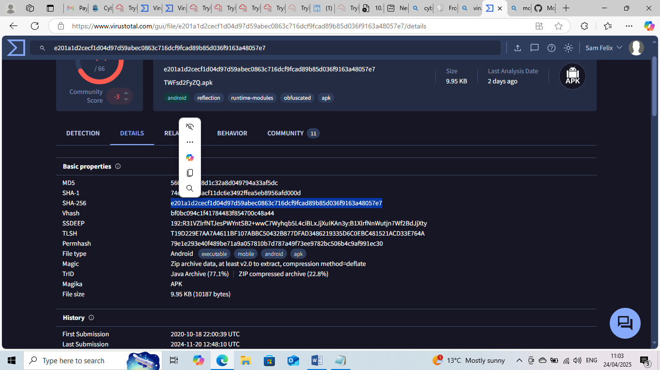

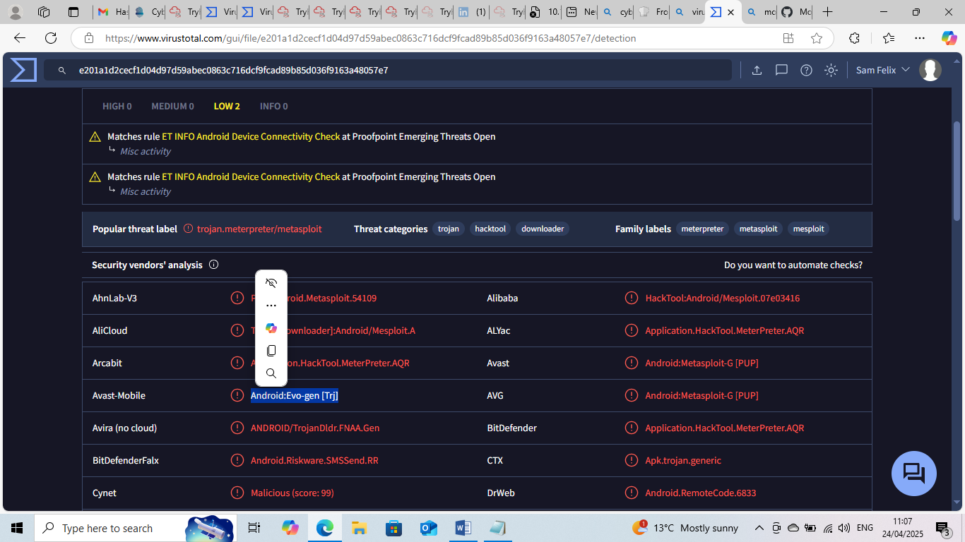

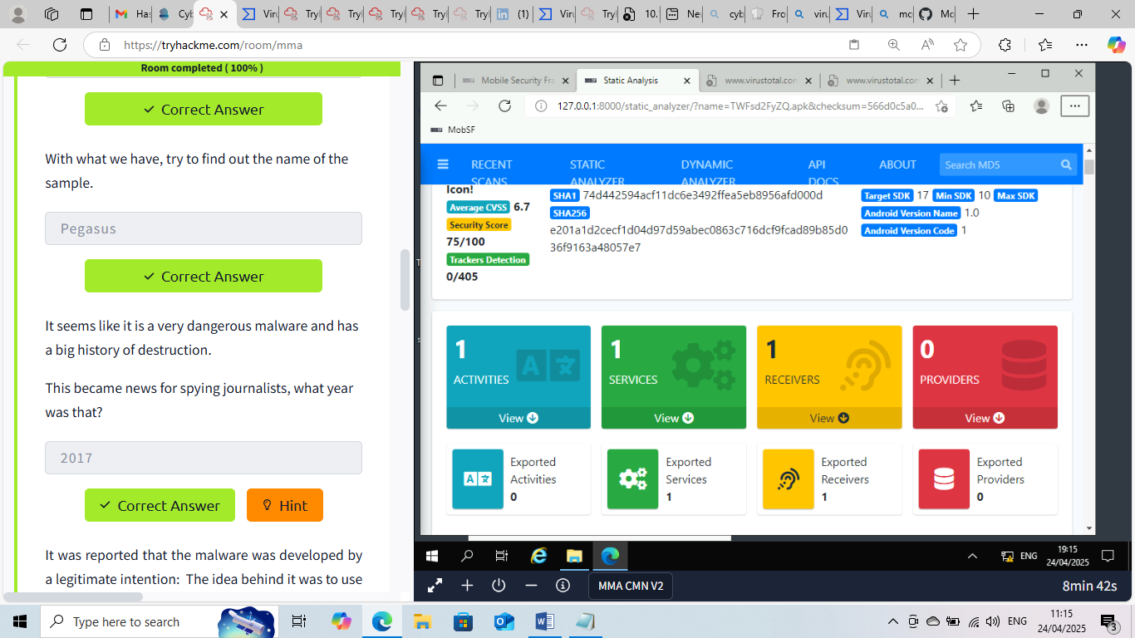

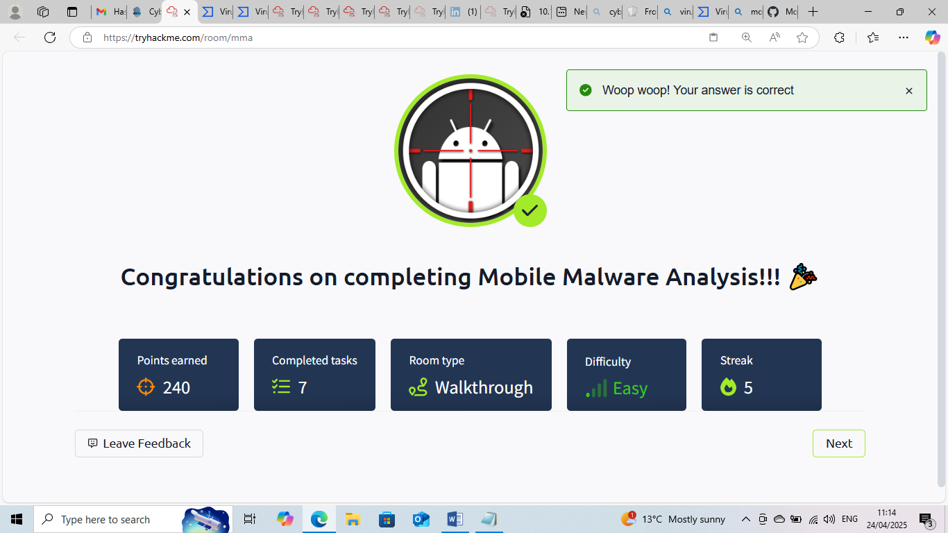

This Internship Task report was developed on [April, 24, 2025]

By:
[ samfelix15@gmail.com ]

